


What impact do the next-day RES projections have on the energy mix?

Aneta Albrechtová
Martin Braun

Co-operating Universities




Financial support by

Prague and Vienna, 2014

Content
Content 2
1. Abstract 3
2. Introduction 3
Motivation 3
Problem statement 4
Research questions 4
3. Background 4
The wholesale price of electricity 4
Shift in merit-order due to RES 4
Regulations affecting the electricity market 5
Czech Republic 5
Austria 5
4. Methods 5
5. Results 6
Examining the German market 6
Case example one – Czech market 8
Case example two – Austrian market 11
Analysis and conclusions for 2013 13
6. Conclusions 16
References (Literature) 16

1. Abstract
The electricity market is defined by complex interactions of forecasts, trade and different forms of production. Our motivation was to examine the effect of renewable energy sources (RES) on the market to deduce effects of an increased share as can be expected in the near future. For the paper at hand we examined the effect of German (DE) electricity production from variable renewables (namely solar and wind) on the Austrian (AT) and Czech (CZ) energy markets using multiple regression models and time series analyses.
After analysing time series of hourly data for 2013, results show that increases in the amount of RES on the market decrease spot market prices. A decrease in spot price was proven on all three markets analysed. From our analysis we can also see that there are seasonal and diurnal influences which are responsible for the main trends in spot market prices. The results also show that RES production directly correlates negatively with spot market prices and is also responsible for stronger fluctuations when prediction error occurs. This means that an increased share of RES leads to cheaper wholesale prices on the market but also creates the need for reliable forecasts and an efficient grid.

2. Introduction
Electricity is an important source of energy and – through being a natural monopoly – is crucial for the national economy with its price affecting a considerable share of an economy as such (Levi-Faur, 1999; Frondel et al., 2009). This paper aims to analyse what effect RES have on the price of electricity on wholesale market. More specifically, it examines whether or not RES decrease spot prices for electricity in CZ and in AT. We would like to elucidate this issue to a wider community. Our paper relies on a number of previous studies and collects their findings.
This work is structured into the following main parts: The first part of our paper elaborates on how the spot market works and how the spot price is created (Background). After a short Introduction we will briefly describe the methods used for our analysis (Methods). In the next part we show the impact of RES on the spot price and typical fluctuations of spot prices during several occasions. We examine the data at hand for the models we used (Results). At last we highlight our results and briefly discuss how the development spot-prices affect the economies examined in this paper (Conclusions).

Motivation
In the last 20 years, the energy markets in Europe experienced many – partly drastic – reforms with efforts to shift energy production from a state-owned monopoly to deregulated structures following the imperative of a free market (Karan and Kazdagli, 2011). Since the adoption of wholesale markets, the market dynamics have become much more complex with three main characteristics of this type of market: Electricity is a commodity with a nearly instantaneous nature, having restrictions on its transmission which make arbitrage difficult; the demand for elasticity is very inelastic in the short-term; the supply is discontinuous and steeply increasing at the high-demand end. Additionally the increased importance and legal favouring of RES as possible measure to mitigate climate change in the long run adds to the complexity of this market.
Because of this, the authors of the paper hope to find out how forecasts on variable RES influence the wholesale market and as a consequence how these developments quantitatively affect the prices on the electricity market.

Problem statement
This paper tries to partly approach the arising complexity by trying to examine how the day-ahead forecasts of RES in DE – through being the biggest potential common RES supplier for CZ and AT – affects the spot-market price of the two countries. As stated in Jónsson et al. (2009) RES are a price maker because of their extremely low marginal costs and thus are believed to dictate the spot market behaviour. Especially because of the high variability of wind and solar power it is of high interest to include the examination of prediction errors on the spot market.

Research questions
The points raised in the motivation as well as the problems stated above lead us to the following research questions:
- What impact do the next-day projections on RES availability have on the energy mix?
- What differences have to be considered in the structure of the markets in CZ and AT (with respect to trade from DE)?

3. Background

The wholesale price of electricity
On the spot market the price is set hourly. On the whole sale market demand is represented by a supplier realising demand for his final customers and supply is provided by individual power plants (producer). The producer is submitting a bid with price and supplied electricity amount at that price. Normally, each producer bids the maximum power of a plant at its marginal costs (MC). The electricity exchange collects all bids and sorts them in ascending order according to the costs resulting in a merit-order curve (Bode and Groscurth, 2006).
The demand is firstly satisfied with the energy from the cheapest power plants in the merit-order. The bid of the last plant – the marginal power plant – that receives a contract determines the electricity price, which is then paid for all contracts that had a price lower or equal to the bid. (Bode and Groscurth, 2006).

Shift in merit-order due to RES
Figure 1 shows market behaviour, if more RES are supplied during day, night and peak times, causing the supply shift to the right. Because of this, the marginal power plant will be the one with lower MC, lowering prices on the wholesale market. As can be seen in the figure the effect is higher for peak hours because of inelastic demand.
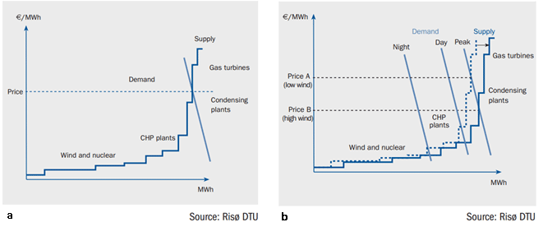
Figure 1 - Effect of RES on the wholesale price. Figure 1a shows the supply and demand cuves for the NordPool Power Exchange, b shows the effect of wind power on the spot price at different times of the day (EWEA, 2010)
Direct effects are, that RES shift the merit order curve to the right, leading to a new equilibrium price (Bode and Groscurth, 2006). In AT and CZ there are additional laws for mandatory purchase of RES from producers. Indirect effects are, that it is harder for more expensive power plants to supply energy especially since CO₂ prices have a significant impact on that part of the industry.

Regulations affecting the electricity market

Czech Republic
The main regulatory body is law 180/2005 Sb. Its purpose is to protect the environment by promoting the use of renewable energy sources. According to this law suppliers (in Czech Republic for example PRE, ČEZ) are obliged to purchase energy from renewable sources. The producer of electricity from renewable sources has the right to choose whether to offer their electricity for purchase for one given price according to paragraph 4 of the law, or whether he will request a green bonus. He can choose between these options once in every year at 1st January. Prices and green bonuses have been declining each year in order to maintain return of investment for 15 years, but not overbid this investment, especially in photovoltaic support.

Austria
In AT three laws provide an important framework for the electricity market. While one regulates feed in tariffs for electricity producers (Directive on eco-electricity feed-in tariffs, ÖSET-VO), the law on Eco-electricity (ÖSG) provides a framework setting compulsory acceptance of renewable electricity as well as incentives for production facilities and plans for expansion in the RES sector. The directive on eco-electricity (ÖSVO) contains additional regulations on prices, effectiveness and reporting.

4. Methods
For AT and CZ we use hourly spot market data for 2013, which we get from AT, CZ and DE wholesale electricity market websites (namely the European Power Exchange (EPEX), Energy Exchange Austria (EXAA) and Operator trhu s elektrinou (OTE) or Power Exchange Central Europe (PXE)).
In this work, we want to examine the effects of variable RES on the electricity markets of Austria (AT) and the Czech Republic (CZ) using historical data for wind and solar power (i.e. the projected wind and solar potential, day-ahead prices, actual production, and spot market prices). We use two illustrative case studies – one for AT and one for CZ – to demonstrate how the market behaves, when the production of variable RES is high. To achieve this we use time series analysis examining the data mentioned above and comparing it with consumption data. In this paper Stata was used to analyse the market in CZ and R for market analysis in AT.

5. Results
At first the German electricity market was examined and findings supported by examples and secondary studies. Then we discuss the influences of this big RES producer on the respective markets in AT and CZ.

Examining the German market
Table 1 shows results of our first regression. Firstly we examine German market, because it has a big influence on Czech and Austrian market and both markets are highly correlated with DE. Results for an analysis of interactions between DE and CZ show, that if 1 more MW produced by photovoltaic power plant is send to the market, price will decrease by 0,0007 €. For example if photovoltaic power plant produced 6217 MW (real production in 11. January 2013), the spot price will decrease by 4.9 €. For wind power production the decline in spot price is even more significant. 1 MW changes the price by -0.0015 €. Another example, when wind power plant creates 15175 MW, spot price decreases by 23 €.
In Table 1 a significant role of the month in changing the spot price is visible. In June the spot price is on average lower by 13.5 € than in January.
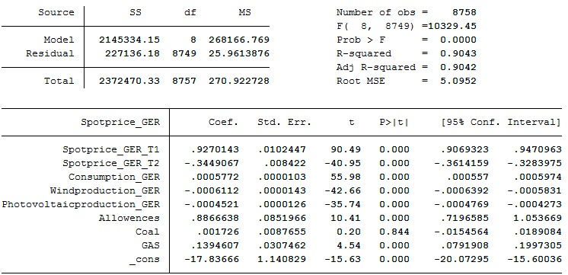
Table 1 - Analysis of monthly averaged spot prices (own analysis A. Albrechtová).
Another method was to examine electricity projections, production and spot price developments, illustrating the effect of prediction errors of variable RES on the electricity market based on one example and then analyse data for 2013.
On 24.03.2013 the solar and wind power produced amounted to more than 30 GW power around noon with the overall projected trade volume with negative prices in the day-ahead market being much lower than the intraday market (Mayer, 2014). Through the actual production being up to 5 GW higher than it was projected day ahead, and the actual grid load was up to 10 GW lower than projected before this resulted in an over-supply leading to lower prices (Figure 3).
The initial situation was a combination of prediction errors for variable RES (error between expected and actual power generation) where the prediction of both wind and solar energy was predicted lower than the actual production was on the next day. Combined with a load projection error this lead to a combined projection error (Figure 3) leading to a massive oversupply and thus a sharp negative peak in spot market prices, which can be seen in Figure 2.
Mayer (2014) examined all pronounced positive and negative effects in the German market for the whole year 2013. Generally, such strong price effects are occurring due to the following reasons: 1) Oversupply due to projection errors, 2) oversupply and problems of base load power plants to go below a certain production capacity due to projection errors and 3) unknown reasons where projection errors are not explanatory for price fluctuations.
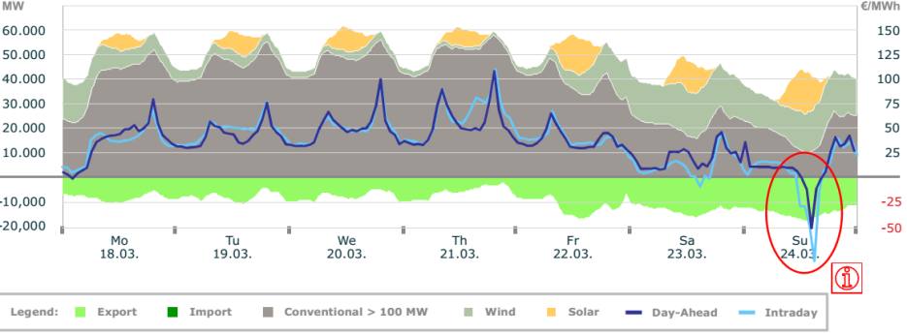
Figure 2 - Electricity production and spot prices for week 39, 2013 (Mayer and Burger, 2014)
As explained in Figure 2, the higher actual production of wind and solar in combination with a lower-than-projected load leads to a bigger total projection error and finally to an oversupply affecting the spot market, which compensates for such deviations through prices.
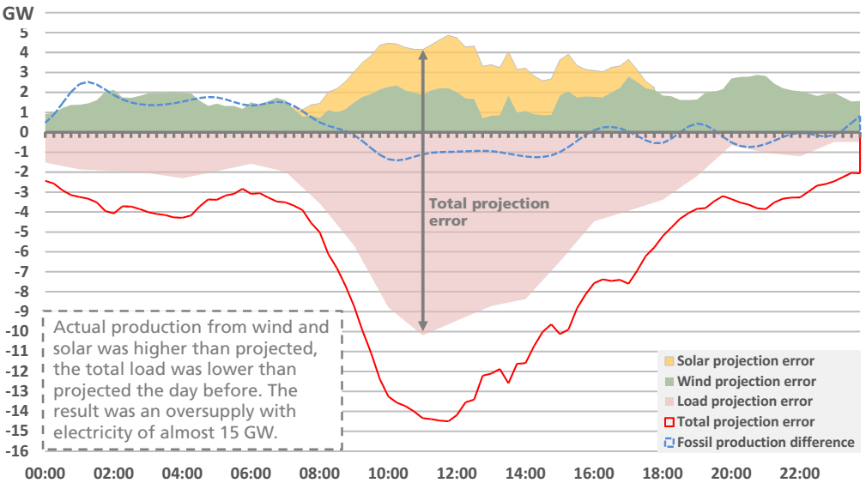
Figure 3 - Actual production/load minus expected production/load on 24.03.2013 (Mayer, 2014)

Case example one – Czech market
For our model the impact of photovoltaic and wind production of electricity on the spot price in DE was examined. Regression was used to estimate this effect and control variables were used for a better estimation, such as prices of CO₂ allowances, spot price of coal, and spot price of gas as well as consumption of electricity in DE. Because precise information was available for each hour of the year, 2013 averages had not to be used.
In the following analysis, the day-ahead spot electricity price from the EEX was used as dependent variable. The German price was used, because it is highly correlated with Czech price as can be seen in Table 2. With a correlation coefficient of about 93 % the Variable for Czech spot price (Spotprice_CZE) is almost perfectly correlated with the variable for German spot price (Spotprice_GER). This proof of correlation and the theoretical background are the main reasons why I examine German electricity market and then I apply the results for Czech market.
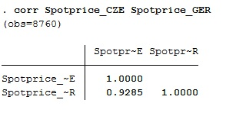
Table 2 – correlation of the German to the Czech spot price (own data and analysis A. Albrechtová)
The estimated equation for our model is structured as follows:
$Spotprice_{GER}=β_{0}+β_{1}Spotprice_{R_{T1}}+β_{2}Spotprice_{R_{T2}}+β_{3}Windproduction_{GER}+β_{4}Photovoltaicproduction_{GER}+β_{5}Allowences+β_{6}Coal+β_{7}Gas+β_{8}Consumption_{GER}+ε$
Where β₀ is the term for intercept, the terms β₁ through β₈ are partial regression coefficients, and ɛ is a random error term.
Our hypothesis states that RES only 1) wind and 2) photovoltaic power plants’ production lowers the spot price of electricity. In Table 1 the results of the regression equation are shown. As shown in Table 1, the coefficient for windproduction_GER indicates, that one additional MWh of electricity produced from wind wholesalers lowers the price of electricity by 0.00061 €. It may seem as a small number, but if it is take into account, that the average wind wholesaler production which is approximately 5,381 MWh, then the price of electricity will decline approximately by 3.28 € (which is roughly 10 % of average spot price). From the small standard error of this coefficient it is obvious that this estimate is highly accurate. These results are in line with the first part of the hypothesis stated.
The second part of the hypothesis was also confirmed when talking about photovoltaic production in DE. From the coefficient of the variable Photovoltaicproduction_GER observe a significant influence on spot price of electricity can be observed. If photovolatic production raises by 1 MWh, spot price of electricity will consequently decline by 0.00058 €. Taking into account average solar production of 3,391 MWh, this means a decline by 1.97 €.
For better understanding the 5th of December was selected, because it had the highest production from RES in the year. The plot in Figure 4 shows the development of spot price during a high portion of renewable energy in the grid. The green line represents production from RES in DE and the red line represents development of spot price on EEX. As you can see, the spot price rapidly decreases from 56 € at 9 a.m. to 40 € at 10 a.m. and decline until it reaches its bottom on 34 € at 1 p.m.

Figure 4 – Spot price development on 5th December. The green line represents the production of RES in DE, while the red line depicts spot prices (own dataset, A. Albrechtová).
At the same time RES production raises from 17,913 MWh at 9 a.m. to 27,250 MWh at 1 p.m. From this data, it is assumed that a 6 € drop in the spot price is associated with a 10,000 MWh increase in RES production.
Of course this shift in price can be caused also by other factors, such as raise in consumption etc. To demonstrate that the decrease in spot price is caused mainly by higher renewable production another graph from the dataset. This time, the 17th of February with very low production from renewable sources was selected and is depicted in Figure 5 showing the development of the spot price. I left the same numeric resolution on both horizontal axes for better explanation.

Figure 5 – Spot price development on 17th February. The green line represents the production of RES in DE, while the red line depicts spot prices (own dataset, A. Albrechtová)
As depicted in Figure 4, RES production has been low for whole day, it reaches its peak at 13:00 with 4,100 MWh. The spot price was very stable for the whole day, it fluctuated slightly around 38 €. Just from 18:00 to 21:00 the spot price crossed the threshold of 40 € which can be explained by higher consumption during these hours.
All other variables are statistically significant in the five percent level of significance except the coefficient for Coal. Firstly, delayed variable Spotprice_GER_T1 showed that if spot price in time-1 changes by 1 €, spot price in time 0 will increase by 0.9 €. For every € increase in Two-times delayed variable Spotprice_GER_T2, there is a 0.34 € decrease in the predicted Spotprice_GER. As you can see from small standard errors, these two variables are statistically significant; this also proves p-value of 0.000 which is fairly below α=0.05.
Variable Consumption_GER says that if consumption of electricity increases by 1 MWh, spot price increases by 0.00057 €. It means that if consumption is for example 52,891 MWh (mean of variable consumption) than price should be around 30.5 €.
The price of allowances also has a significant impact on spot price of electricity. Its coefficient indicates that during 1 € increase in the price of allowances, spot price will increase by 0.89 €. The upper bound of the confidence interval shows that 1 € increase in price of allowances can raise the spot price of electricity by a factor of 1.05. It may seem, that the price of allowances changes the spot price markedly, but the average price of allowances is around 4.49 €, and the price fluctuates just slightly because 95 % of prices is ± 0.67 € from the average price.
Coal is the only variable from the model which is not statistically significant, because it has large standard error and p-value is higher than α=0.05. On closer examination, it was found that the data in the variable coal contains futures. It means that prices which have been trading in 2013 have been trading for the year 2014.
The last coefficient which have significant impact on spot price of electricity is the price of GAS. It suggests that with a 1 € raise in the price of gas, the electricity spot price will grow by 0.14 €.
Large F-value 10,329.45 rejects the hypothesis of the overall insignificance of the model with the probability of insignificance lower than 0.0000. R² is very high with a value of 0.9043. This value indicates that 90 % of the variability in dependent variable Spotprice_GER can be predicted from the variables independent variables Spotprice_GER_T1, Spotprice_GER_T2, Consumption_GER, Windproducstion_GER, Photovoltaicproduction_GER, Allowances, Coal and GAS. As can be seen, the value of adjusted R² is almost the same as the value of R², which means that the number of observations is very large compared to the number of predictors.

Case example two – Austrian market
In a first step, potential effects of Austrian RES on Austrian spot prices were analysed. We used hourly time series for wind projections and actual production as well as grid forecast and grid load. To find a potential relation to extreme EXAA price developments we normalised prizes according to the formula below and looked for deviations of greater than three (48 occurrences).
$${Price}_{norm}=\frac{x_{i}−μ}{σ}$$
For these occurrences anomalies in the prediction of Austrian wind production to the actual wind production as well as projected grid load and actual grid load were investigated. Because the prediction errors were not significantly different from prediction errors outside the 48 occurrences we conclude, that there is no significant domestic RES influence on the spot market price.
This suggests that RES-driven price fluctuations are likely to be influenced by the German market. Using the information from the examination of the German market we can investigate German and Austrian market interactions. Since on an average 2013 day the traded volume on the Austrian market is about 3.2 % from the volume traded on EPEX-spot, and with regard to the different organization of both exchanges, the Austrian market is used as a first possibility to secure bids at EXAA (since auctions are earlier than on EPEX) where uncertainties can be levelled out on EPEX-spot, while EPEX-spot is dictating the large-scale fluctuations because of the small share of the market.
Because this levelling out seems to be negligible, a cross-correlation analysis between the two time series was performed. The cross-correlation between hourly time series data for EEX and EXAA spot prices was computed resulting in a high correlation of 0.94 for a lag of zero (cf. Figure 6). Since negative prices were not possible at the EXAA before 15. October 2013, prediction errors resulting with an oversupply are reflected with prices of 0.01 (lowest possible price) before this date. Comparison with events identified by Mayer (2014) show, that the predictions for the EEX have a strong impact on EXAA (where auctions are held at 10:15 in comparison to EPEX-Spot, where there are held at 12:00; Kattinger, 2011).
Since the energy market generally shows the same consumption-related pattern with seasonal variation (with peaks around 8-9 and 18-20h) there is also a higher correlation in the shifted time series (with the large peaks being about one day, and the smaller being overlaps between morning and evening)
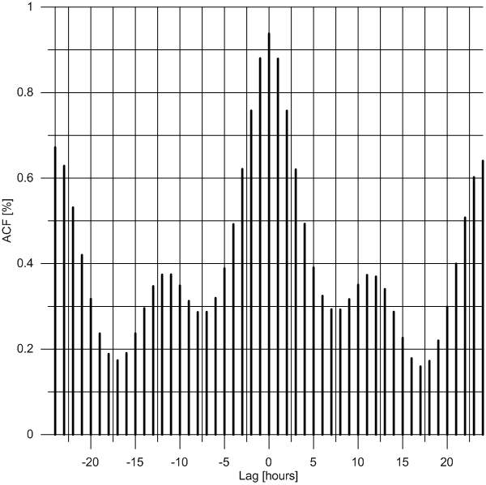
Figure 6 - Time-series correlation of EXAA and EPEX Spot prices for a year. Lag is depicted in ± 24 hours, correlation is highest at a price lag of 0 hours with 93.8%; (own analysis M. Braun, data: EPEX Spot, 2014a; 2014b; EXAA, 2014)
Based on information provided by Mayer 2014 the influence of variability in German RES production on the Austrian market was analysed. Because the data was not readily available, analyses were only made for the deviations mentioned in Mayer’s study (in form of weekly time series) to see if there is some effect.
For Austria, our analysis shows, that there is an influence of EPEX price on EXAA and that there is an influence of RES predictions on the grid. The time-series cross-correlation analysis shows that the EPEX Spot prices are correlates with the EXAA prices by 93.8 % (cf. Figure 6). A regression of the differences of the respective time series also showed a highly significant correlation (Figure 7a), while the R²-value is lower for the analysis of correlation of differences of the time series data, but still shows a correlation of about 89 % (Figure 7b)
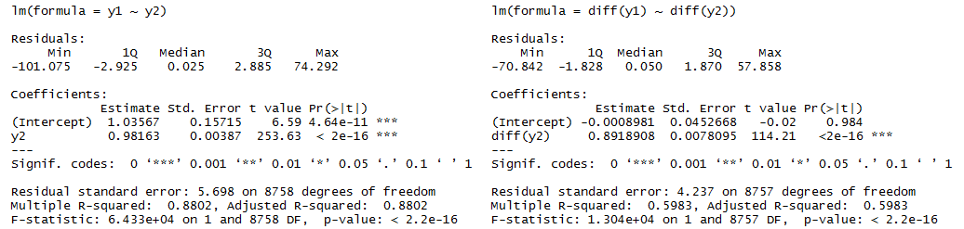
Figure 7a – Linear model correlation of the EPEX and EXAA time series, Figure 8b correlation of differences of the EPEX and EXAA time series (own analysis M. Braun, , data: EPEX Spot, 2014a; 2014b; EXAA, 2014)
Because of these analyses we conclude, that fluctuations in the German spot market have a highly significant impact on prices of the Austrian market.
As we saw in the analysis of RES on the German market and exclude the cases with unknown caus, it is clear, that such strong fluctuations are predominantly caused by next-day prediction errors for RES availability. The strong fluctuations are a mechanism of the market to level out such fluctuations.
When looking at the grid load curves, variable RES don’t seem to affect the temporal distribution of the grid load noteably. As can be seen in Figure 9 the morning and evening peaks are still dominant.

Analysis and conclusions for 2013
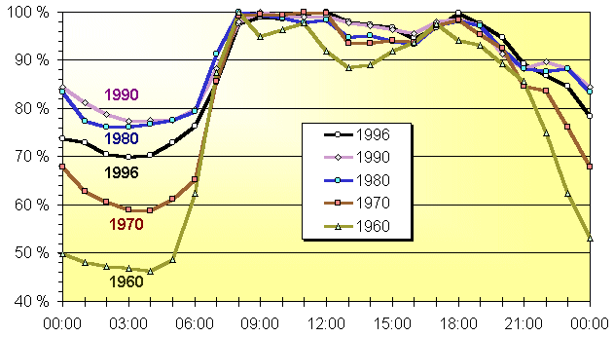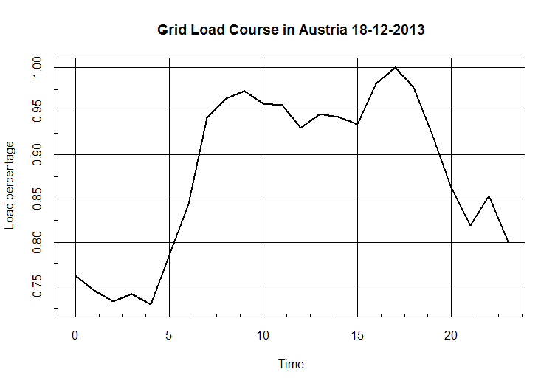
Figure 9 – (a) Course of the grid load in DE for each 3rd Wednesday of the respective year relative to the day-maximum (VDEW after Quaschning and Hanitsch 1999, before 1996 only Federal Rep. of Germany). (b) Course of the grid load in Austria for the 3rd Wednesday of Dec 2013 (data: EXAA 2014, illustration: M. Braun)
We can see, that there the day-time ditch is decreasing, but we lack information to draw conclusions from the change. We can only speculate, that a higher energy demand (e.g. from domestic appliances and generally more electronics) is responsible for an overall higher grid load percentage.

To finally determine, if there is an influence of German variable RES on the EXAA spot price, the differences of predicted variable RES production (since day-ahead prediction mainly determines the price; Mayer, 2014) and Austrian prices are highly correlated. Because the data was not readily available, December and June were chosen as representative months since generation from wind has higher potential in winter and solar generation has higher potential in summer (Mulder, 2014; Heide et al., 2010).
As the combined time series chart for December suggests, wind production seems to negatively correlate with the monthly course of hourly EXAA spot data, while the expected solar production negatively correlates with the daily course of hourly EXAA spot data, which is easily explainable through the course of daily insolation.
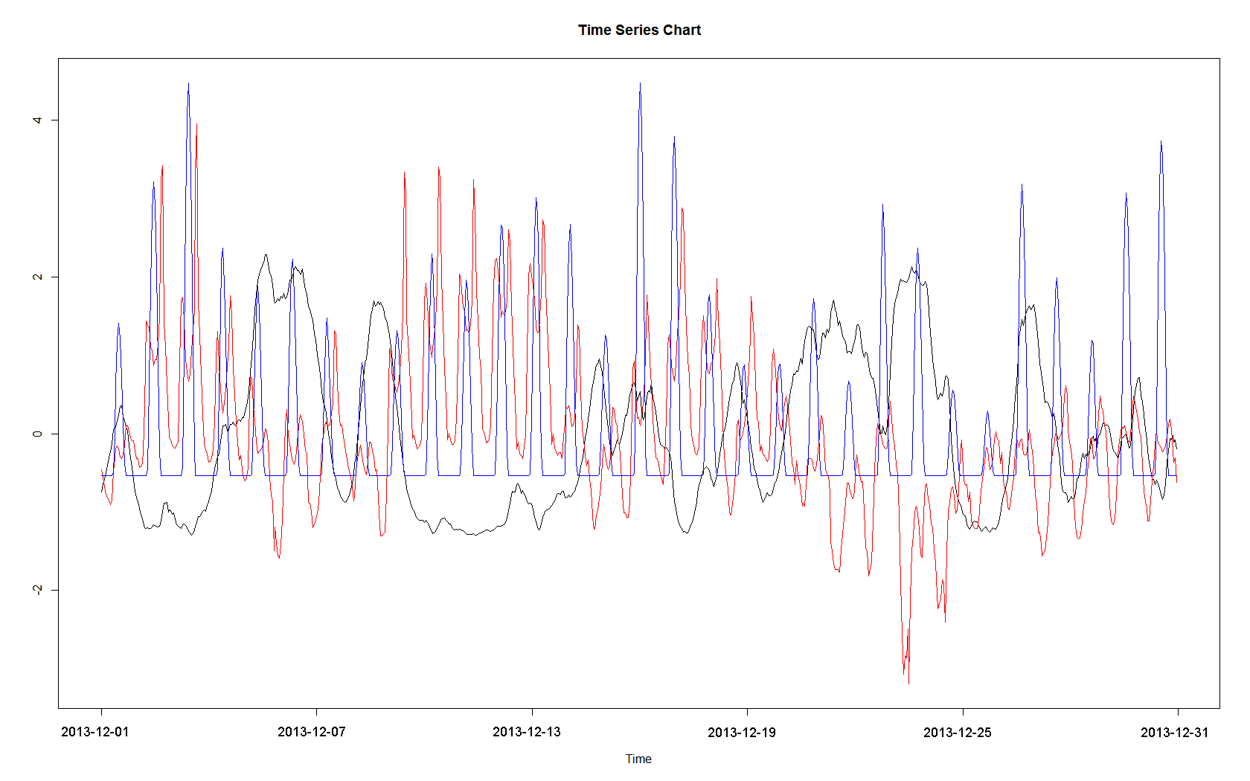
Figure 10 - Time series chart for December showing standardised time series for expected wind (black) and solar (blue) production as well as spot prices (red; data: EXAA, 2014; illustration: M. Braun)
A cross correlation between data from wind and negative EXAA spot prices shows the suggested correlation. Because of intra-day variability the correlation is just around 52 %.
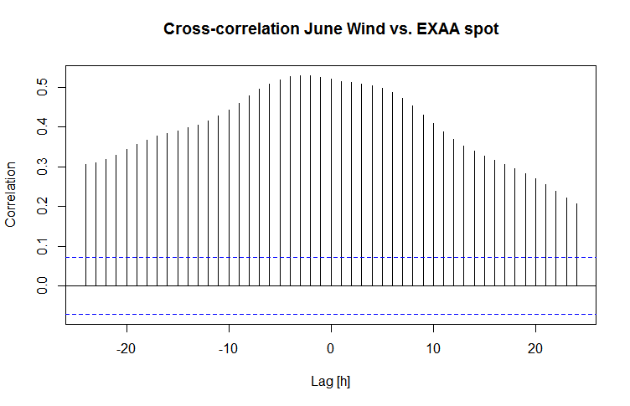
Figure 11 – Cross correlation for December time series of the wind time series and negative EXAA prices (own calculation M. Braun, data: EXAA 2014)
Next-day forecasts for solar production correlate with about 21 % with time-series cross correlation, since the effects of solar production on the price are overlaid with the prices being affected by the diurnal course of electricity demand. As depicted in Figure 9 the demand, which is shaped by peak morning, lower business day, peak evening and very low night courses is the main driver for the shape of the price time series. The rest of the variation then mainly correlates with wind (52 %), while solar affects the already lower prices between the morning and the evening peak, this effect is best seen when applying a linear regression of differences of the standardised solar production and the standardised EXAA spot price.
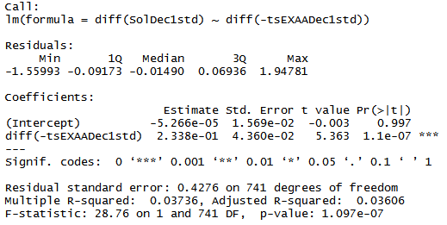
Figure 12 –Correlation of diffrences in projected solar production and differences of the EXAA spot price (own calculation M. Braun; data: EXAA, 2014)
This analysis shows a correlation of the expected solar production to the EXAA spot price of about 23 %, while the time-series cross-correlation showed about 21 % representing the ditch of EXAA price for German solar forecast peaks. The calculations were conducted for the two representative months June (summer) and December (winter). All our results are summarised in Table 3.

 | June | December
Average; max solar production | 6078 MW; 23300 MW | 1022 MW; 9605 MW
Average; max wind production | 4746 MW, 16632 MW | 10014 MW, 26148 MW
EXAA average; min price;  price at max wind; price at max solar | 27.8 €, 0.01 €; 36.49 €; 49.94 € | 35.7 €, -32.45 €; 31.4 €, 9.88 €
Time series cross-correlation EPEX; wind; solar vs EXAA | 87.8 %; 44.6 %; 11.3 % | 94.3 %; 52 %; 17.4 %
Linear model EPEX; wind; solar vs. EXAA (standardised) | 87.5 %; 44.6 %; 11.3 % | 94.3 %,52 %;17.4 %
Linear model EPEX ; wind; solar vs. EXAA (differences from standardised data)* | 76.4 %; 10.2 %; 12.8 % | 79.6%; 0 %**; 23.3 %
Table 3 - Summary of results for Austria. The compared variables were EPEX and EXAA spot prices, next-day wind projections, and next-day solar projections. *this method is more suitable to find influences from solar since wind is influencing the course of the price while solar has en effect on price differences during solar production; **not significant (own calculations M. Braun; data: EXAA, 2014)

6. Conclusions
Our investigation showed that next-day projections have a high influence on the spot market prices and thus RES availability. It can occur, that prediction errors can lead to a large cumulated deviation of expected electricity generation (if the cumulated deviation of RES projection and load projection is high enough). In a diversified market this usually leads to strong price fluctuations, which level out the deviations caused by prediction errors: If the actual production minus the predicted production is negative, this means that an over-prediction had occurred, leading to higher prices and imports of cheap energy. If the deviation is positive, an overproduction will occur and the excess production has to be absorbed through bulk storage or exported.
Furthermore, the share of variable RES is projected to increase in the future, especially in the European Union where the 20 by 2020 goals are an ambitious plan to mitigate climate change effects. Our results are in line with other studies (e.g. Kloess and Zach, 2014). This study also confirms the result that EXAA prices are highly correlated with EEX prices due to the high interconnectedness of the grids. Combined with bulk electricity storage technology going towards an increased share of variable RES is a viable path for the future. Without continuing development of such, negative impacts on grid stability are to be expected.
To effectively increase the share of renewables, a diverse grid has to be implemented. This means diversification of providers as well as the proper energy mix to account for base load, variable RES and methods to shift the electricity produced by RES to be partly available when needed and provide solutions for transmission system operators to meet the challenges of a decentralised, but weather-dependent production. The energy transition in DE will affect also its neighbouring countries and have an impact for the whole European energy market. During recent years the German grid became congested because of the large increase in RES production, where particularly large wind parks in northern DE exceeding the consumption were the cause. Adjacent grids were not prepared to deal with such peaks and thus lacked the capacity to efficiently deal with variable RES (Adaduldah et al., 2014).
With respect to the second part of our research question our analysis indicates, that AT has more possibilities to cope with RES fluctuations and thus has a higher resilience. If CZ will further integrate its market with respect to interconnectedness, ways have to be found to absorb such fluctuations and utilise them when needed. Another way would be to halt further integration to ensure that a status-quo grid will not be affected. Because of the importance of RES for the energy market the answer to questions of interconnectedness and resilience will lie in a common European approach.

References (Literature)
Adaduldah, N.; Dorsman, A.; Franx, G.;Pottujit, P. (2014): The Influence of Renewables on the German Day Ahead Electricity Prices. In: Dorsman, A.; Gök, T.; and Karan, M. (Eds.): Perspectives on Energy Risk. Heidelberg, New York: Springer.
EPEX Spot (2014a): Market data intraday. Germany/Austria [Available online]. URL: http://www.epexspot.com/en/market-data/intraday/intraday-table [Last access 29.09.2014]
EPEX Spot (2014b): EEX Transparency Platform [Available online]. URL: http://www.transparency.eex.com/en/ [Last access: 08.03.2014].
EWEA – European Wind Energy Association (2010): Wind Energy and Electricity Prices. Exploring the ‘merit order effect’ [Available online]. URL: http://www.ewea.org/fileadmin/files/library/publications/reports/MeritOrder.pdf [Last access 29.03.2014]
EXAA (2014): Historical Data. Market Data [Available online]. URL: http://www.exaa.at/en/marketdata/historical-data [Last access 29.03.2014].
Frondel, M.; Ritter, N.; Schmidt, Ch.; and Vance, C. (2009): Economics impacts from the promotion of renewable energy technologies: The German experience, Ruhr economic papers, No. 156., p.1-34.
Heide, D.; von Bremen, L.; Greiner, M.; Hoffmann, C.; Speckmann, M and Bofinger, S. (2010): Seasonal optimal mix of wind and solar power in a future, highly renewable Europe, Renewable Energy 35(11), p.2483-2489.
Jónsson, T.; Pinson, P. and Madsen, H. (2010): On the market impact of wind energy forecasts. Energy Economics 32 (2), p.313-320.
Karan, MB. and Kazdagli, H. (2011): The development of Energy Markets in Europe. In: Dorsman, A.; Westerman, W.; Karan MB. and arslan, Ö. (Eds.): Financial Aspects in Energy. Berlin, Heidelberg: Springer.
Kattinger, M. (2011): Österreichs EXAA lebt vom Spotmarkt. Neue Zürcher Zeitung, 5. May 2011.
Kloess, M and Zach, K. (2014): Bulk electricity storage technologies for load-leveling operation – An economic assessment for the Austrian and German power market. Electrical Power and Energy Systems 59, p.111-122.
Levi-Faur, D. (1999): The Governance of Competitions: The interplay of technology, economics, and politics in European Union electricity and telecom regimes. Journal of Public Policy 19 (2), p.175-207.
Mayer, J (2014): Electricity Spot-Prices and Production Data in Germany 2013 [Presentation, online]. URL: http://www.ise.fraunhofer.de/en/renewable-energy-data/electricity-production-data?set_language=en [Last access 25.03.2014].
Mulder, F. (2014): Implications of diurnal and seasonal variations in renewable energy generation for large scale energy storage. Journal of Renewable and Sustainable Energy 6(033105), p.1-13.
Quaschning, V and Hanitsch R. (1999): Integration regenerativer Energien in die Elektrizitätsversorgung. BWK – Das Energie-Fachmagazin 10/1999, p.64 [online]. URL: http://www.erneuerbare-energien-und-klimaschutz.de/artikel/lastmanag/index.php [Last access 13.05.2014]
Vitásková, Alena (2013): NAVRH. Cenové rozhodnutí Energetického regulačního úřadu č. …/2012ze dne … . listopadu 2012, kterým se stanovuje podpora pro podporované zdroje [online]. URL: http://www.opravymve.cz/wp-content/uploads/121025_Navrh-CR_POZE_pro-2013.pdf [Last access 19.06.2014]

The data source for CZ was not specified although requested on 31.03.2014 [M. Braun].
Futures contracts are an agreement between two parties to buy/sell a standardized quantity of a commodity at a given price on a given future date. Futures contracts always provide a physical delivery. The buyer of a futures contract is committed in specified time to take over the amount of the underlying asset (such as coal) at a specified price. The seller undertakes to deliver within the specified time the amount of the underlying asset at a specified price.
Solar production was not included because production in Austria is to small to be reported.
We also chose the 3rd Wednesday of Dec 2013 to have a comparison to the historical grid courses, to see if there is a change before RES were introduced.
Negative prices in EXAA have been introduced in 15. October 2013; the minimum possible price before was 0.01 €

