Economical perspectives of energy storage systems for wind and solar energy
in Central Europe

Lenka Šperková

Co-operating Universities
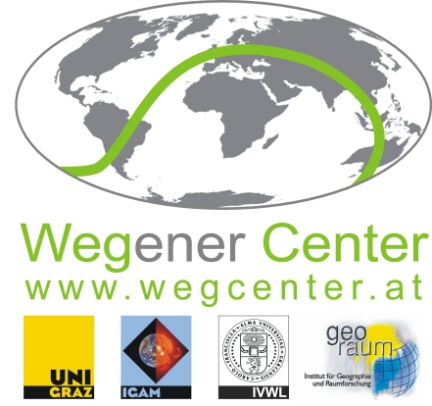




Financial support by

Prague and Vienna, 2013

Content
Content 2
1. Intruduction 3
2. Abstract 3
3. European and Central-European framework for renewable resources support 4
3.1 Strategy plans in renewable energy sources implementation 4
3.2 Innovation and new technologies 6
4. Motivation for energy storage 6
5. Types of energy storage systems 9
6. Literature review 10
7. Methodology 10
8. Economic evaluation of energy storage 11
9. Conclusion 13
10. References 15

Intruduction
Scarcity of energy sources along with wide application and increasing capacity of renewable energy sources generated number of challenges which did not always resulted only into positive externalities. Plans for gradual CO2 emission reduction and regional geographical predispositions have facilitated concentration of wind and solar plants into the selected areas with favoring conditions. Large renewable energy sources (RES) production fluctuations and density of energy infrastructure contributed to concerns about general European energy safety. There were developed number long term strategies focusing of minimization of those problems. To the most developing concepts belong energy storage systems as an alternative solution for large energy production fluctuations as well as possible future technology energy sustainability. In our paper we would like to introduce basic concepts related to energy storage systems along with economical evaluation of their cost requirements.
In the first section we will provide an overview of European strategies connected to promotion and support of renewable energy source along with description of current status especially in the Central Europe. The fact that process of RES adoption was not without complication and that there are possible externalities arising from large concentration of RES was reflected in the set of problems which have become priorities of selected European projects including ESS development.
Second section is dedicated to energy storage systems and their technological and economical characteristics. Motivation of energy storage is not limited to one area of interest. Therefore we will provide an overview of the most of possible application of ESS connected not only to current, but also to future perspectives.
Major part of our paper strives to reflect techno-economical comparison of selected types of energy systems and application on RES (especially wind end solar energy) in countries of Central Europe (Austria and Czech Republic) and Germany. Framework of our model is based of evaluation analysis by Sandhya Sundararagavan and Erin Baker (2012) applied on selected countries. Results of this study are reflected with possible challenges not only in the model, but also within whole area.
In the conclusion we will summarize our findings along with their discussion with respect to existence of supporting projects and international (European) subsidies.

Abstract
In recent years European Union and especially middle Europe have experienced rapid penetration of renewable energy systems through a strong support of government subsidies. The desired shift from fossil to renewable sources of energy was accompanied by irregularities in energy supply caused by increased dependence especially on wind and sun conditions resulting in an increased demand for storing energy. This assessment evaluates the potential of different energy storage systems for balancing intermittent renewable energy production based on technological and geographical feasibility together with economical competitiveness. Results of our analysis include low cost perspective of pumped hydro and compressed air technologies. Nevertheless there is strong need to reflect our results in wider perspective (especially financial and technological). Finally the survey discusses the characteristics of the interrelation between energy storage facilities and the electricity market under current European legislation followed by an outlook on how policies can encourage the penetration of storage capacity into the energy system for achieving sufficient flexibility in energy management

European and Central-European framework for renewable resources support

Along with technological and economical development (consisting especially from increasing welfare level) in recent years we have experienced increasing energy requirements which need to be satisfied by increase in energy production. Local and international authorities (in our case European Commission) have been also aware of decreasing supplies of fossil fuels and increasing pressures on global environmental sustainability and especially of need to develop supranational strategy plan that would reflect all facts and help national bodied to improve this state towards optimal “balance state”. First attempts in European area are dated to 1997 to White Paper with overall target 12% of energy produced from renewable sources in EU-15.

  - Strategy plans in renewable energy sources implementation
In the 2009 European commission issued directive 2009/28/EC which has required to be implemented into national legislation systems by 2010. Main target of this directive has been revolving around increasing proportion of renewable energy resources applied on national energy grids and about general support of them. One of the main targets of this Action plan introduced main targets

“a key objective of the Community, and the aim is to achieve a 20 % improvement in energy efficiency by 2020 …10 % target for energy from renewable sources in transport…and 20 % target for the overall share of energy from renewable sources”

accompanied by sets of support and subsidies schemes for easing their application.
But wider attention has been gained in 2009 by issuing general climate action plan 20-20-20 which stated:
- 20% reduction in EU greenhouse gas emissions from 1990 levels
- Increasing proportion of EU energy produced from renewable resources to 20%
- 20% improvement in the EU's energy efficiency.
In addition to this statement EC introduced indicative trajectory, already adopted by member states, depicting planned progress in implementing goals in which have been reflected national energy specifications and limits: for Czech republic planned proportion of RES (renewable energy sources) of final energy consumption 13,5% and for Austria 34.2% by the end of 2020. EC has left relatively wide range of competence in instruments used by implementation and realization those targets. Result of this was significant diversity in national energy action strategies which respected natural heterogeneity of countries.
As a consequence we may have experienced especially in the Central-European region dramatic increase in wind and solar energy installed capacity. In 2012 Global Wind Energy Council (GWEC) reported highest increase in year-to-year installed wind power capacity by 44.7 GW and by 30 GW in solar energy capacity (EPIA). Those facts rank wind, solar and gas energy to the most progressively growing sectors in energy production industry.

Global trends just reflect Central-Europe situation experiencing increasing trend in wind and solar power installations widely supported by EU subsidies. It is expected that the most significant increase would be detected in off-shore areas which includes countries like Germany, Poland, Baltic countries with most suitable conditions. Leader in this area in undoubtedly Germany with installed capacity 2,439 MW out of European total in height of 106 GW.

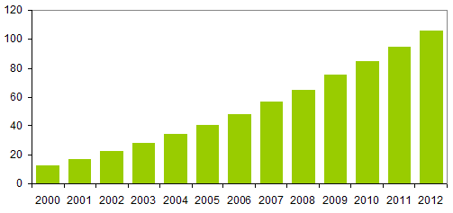

Figure 1: Cumulative wind power installations in EU (GW)
Source: Wind power 2012: Energy statistics - EWEA

  - Innovation and new technologies
Together with promotion and support of RES by issuing series of directives and action plans EC sets another priority in endorsement of innovation technologies across sectors which in our case includes energy sector innovation. In cooperation with CORDIS (Community research and development information service) EC launched series of programs which strives to facilitate research and development in energy sector.

7th framework program was introduced for period from 2007 to 2013 as a successor of 6th framework program in order to transform current energy systems into more sustainable pattern with low CO2 emissions characteristics along with supporting technologies enhancing energy conservation and efficiency.

SET-plan or strategy energy technology plan focuses besides non and low carbon technologies on international cooperation in energy sector: “to planning, implementation, resources and international cooperation in the field of energy technology”. Leading project of SAT is information system SETIS which supports whole pattern of projects from planning stage to final implementation and consultation of policies in the case of need.

Generally one of the most ambitions projects covering this area revolves around research and development of energy storage systems and possibility of their effective implementation into current transmission systems.

Motivation for energy storage
Despite the fact that actual application of energy storage system has been very limited to single or “prototype” projects it is possible to identified major motivation factor which would contribute to further development of either devices it selves or legislation and supporting projects facilitating its financing and application.

As we have already mentioned major potential currently recognized in energy storage systems (ESS) revolves around recent high penetration of renewable energy sources into electricity grid. Acknowledging divergence in geographical typology between different states of Central Europe, there can be observed high potential for various forms of RES. Germany and Austria assigns common characteristics of wider wind power energy predispositions along with larger installation of small solar energy devices. Opposed to them Czech Republic has crucial geographical shortages for wind energy application which has been limited to specific areas. On the other side Czech legislation n. 180/2005 allowed massive large scale solar energy installations which compared to similar regulations in neighboring states were not limited by installed capacity (for example to 30kW). Later amendment from 2010 has restricted major shortages of is forerunner nevertheless there remains large proportion of subsidies solar energy.

Despite national and regional differences RES in all countries indicates one common factor: fluctuations in energy production which deeply depend on meteorological and geographical conditions. Those facts strongly influence shape of energy production and price development function not only on yearly (monthly) but also on daily basis.
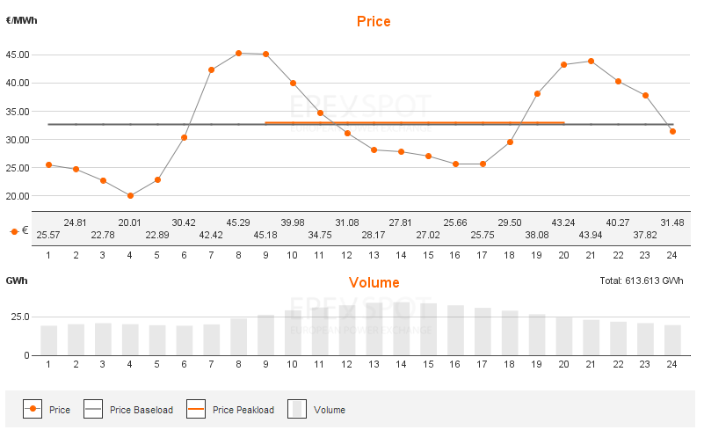

Figure 2: Solar energy: production and price (24 hours development)
Source:http://www.epexspot.com/en/market-data/auction/chart/auction-chart/2013-04-25/DE

More than illustrative example can be found on German/Austria European power exchange where we see course of one sunny day (Figure 2). There can be seen strong impact of RES on daily production represented especially by solar energy with peak around 14th hour which determines price development and generates space for potential speculative motive within auction.
However may seem solar energy (and photovoltaic generally) systems volatile they posses important aspect of partial predictability. There are common meteorological patterns according to which we can predict productivity of separate plats: assumption of highest production level during around specific hours and long term weather development experience. In contrast to them stands unpredictability of wind development and strong oscillations of wind energy plants production determined by this fact (Figure 3). Difference between day and also longer term peaks makes wind power energy the most promising and challenging area for ESS implementation. Advantage lays in need for short term energy storage (mostly on minutes-hours basis). It should be not surprising that existence of number of studies and small scale application can be found. During this year it is to be launched world’s largest power storage system in Texas, USA. Storage systems will be used together with wind energy plants and potential capacity is expected around 153 MW. On European level majority of projects stays in the stage of development or prototype, nevertheless there already exists supporting programs: project stoRE, Intelligent Energy Europe or platforms revolving around smart grid.

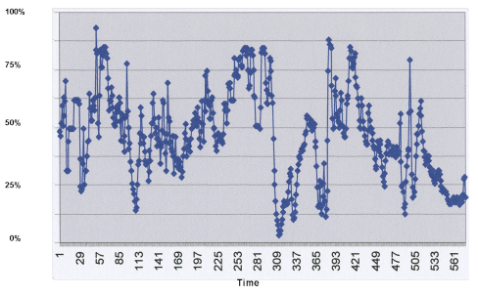
Figure 3: Wind power energy production fluctuation (in 5 min intervals)
Source: Incoteco, Demark. Available at: http://whitherindustrialwindpower.wordpress.com/m-offshore/

Despite attraction and potential of ESS application on RES along with balancing of energy supply on short and long term basis, motivation for their wider application should not be restricted only to single area of use. To the most discussed topics on European level belong energy transmission and problems arising from characteristics and specifications of European transmission systems especially on the international (cross border) level. Economical, legal and geographical differences along with diversity of national strategies have made European energy transmission systems very heterogeneous environment, which assigns one important aspect: scarcity. Inability of regulation of energy flows on the national borders has generated number of problems arising from local (national) increase in filling of capacity reaching the sustainable level. Despite existence of systems preventing national and international “black outs” there is need to develop a long term strategy either contributing to easier infrastructure development or decreasing short term level of capacity usage. ESS application would in this case contribute to reduction of potential problems by creation of capacity gap in exposed sections at least on the hour or daily basis as well as energy safety. ESS advantage revolves around “non-invasivity” of those pattern opposed to systems which fully or partially deflect energy flows.
Acknowledging nature and range of impact of this problem, there have been made improvements especially in the area of automatic (intelligent) systems for auction of capacities and tendencies to integrate national systems into larger units, which have already contributed to reduction of speculative motive in cross border energy transmission and problems accompanied.
Motivation of ESS application is not restricted only to current projects needed in the present. To the future challenges belongs generally wider installation of ESS as a strategy accompanying reduction of CO2 emissions as well as enabling of small scale energy storage for household or smaller units. Technological development continuously shifts possibilities of discharge time in selected storage techniques and generates space for eventual long term energy storage (in the rage of months or years) as well as potential of energy sustainability and national energy safety in Europe.

Types of energy storage systems
Although might systems of energy storage appear to assign complicated and sophisticated dimension of construction and technological requirements connected to “new generation” technologies, we might find relatively efficient patterns dated up to 1970 or even older. Location of those projects was not restricted to Eastern Europe or USA. In the former Czechoslovakia we might have found example of pumped hydro storage system known as “Dlouhé stráně” which is dated till 1978.
In our paper we will focus on three major types of energy storage systems. Besides already mentioned pumped hydro storage systems (PH) there are compressed air technologies (CAES) which have been recently realized in USA (1991) or in Germany (1970’). Despite extremely high initial costs of both systems they assign lowest “operational” costs connected to actual storage technique and services which might in the long time period contribute to price lowering. Predispositions of both systems allow extending of discharge time from hours to days and would in the future facilitate long term energy storage. Application of EEC on RES on the daily basis especially in the area of balancing disproportions in the production does not require extremely high discharge time. An efficient short term storage technique facilitating this usage could be batteries.
Opposed to usual perspective on batteries usage technological development facilitated improvement contributing to increase in potential storage capacity in both dimensions: volume and time. Therefore it is possible to extend discharge time up to hours or days. Technological characteristics of batteries do not facilitate long term energy storage, but opposed to preceding category do not have high space and geographical requirements. This advantage is more than compensated by high operational and service cost which states question regarding their contribution to price lowering as well as the area of usage. We might find two major types of battery systems: to the first category belongs lead acid, lithium-ion, nickel–cadmium, sodium sulphur battery. All types assign lower discharge time in the range of minutes but relatively large capacity scale up to 1MW. Flow battery systems represent second category (Zinc bromine flow and vanadium redox flow battery). Opposed to first type they have longer discharge time and higher capacity which is on the other side compensated by lower variability in the choice of range of capacity.
Technological parameters of all types diverge and therefore states different areas of usage with respect to their efficiency, capacity and discharge time but also to cost requirements

Literature review
Necessity of energy usage and existence of scarcity of energy sources has made energy systems as well as storage systems one of the most developing sectors in recent years. Nevertheless interest has not been restricted technological improvements and developments of new storage techniques but also to implications for current ESS installation. Existence of various storage techniques has generated large space for analysis of their application on the national level with different geo-political and economical conditions along with renewable energy sources (especially wind and solar energy). Francisco Díaz-González, Andreas Sumper, Oriol Gomis-Bellmunt, Roberto Villafáfila-Robles published in 2012 large overview summarizing major types of energy storage systems applicable on wind energy balancing. Along with list of those technologies we might find deep analysis of their technological characteristics connected to actual process of energy storage. Arturs Purvins, ect. (2010) widened analysis by focusing on regionally specific European energy systems application along with generating of proper energy management. Despite existence of energy storage technologies and RES increasing capacity there has been recognized strong need for deepen integration in this area as well as development of energy management. Inclusion of market difference and general economical perspective was reflected in study of L. E. Benitez, P. C. Benitez, G. C. van Kooten (2007) in which new nonlinear mathematical program was developed in order to improve evaluation and investigate impact of wind power and ESS (especially pumped hydro systems). To the most complex techno-economical analysis of storage systems belongs study of S. Sundararagavan and E. Baker (2012) including majority of know energy storage systems in simple economical model which estimates costs requirements of each technology with respect to technological and economical differences.
Along with already mentioned studies it can be found number of alternative analysis focusing not only to specific types of RES or ESS but also on their actual application on national or international level.

Methodology
With respect to complicatedness of studied problem we have decided to provide an analysis of currently available storage systems and their categorization according to their technological and economical parameters. In the first section we would like to dedicate technological aspects of ESS, especially their major types and categorization. In following part we would like to provide an economical analysis based on the most significant technological and economical factors and their synthesis in simple model which would estimate main cost requirements and contribute to their further categorization.

Continuous development accompanied with unavailability of sufficient number empirical implementation (usually limited to specific countries and RES) makes construction of appropriate model difficult process. Therefore we have decided to provide a meta-analysis based on recent acts in this field. ESS field has become of the most dynamic energy sectors which would contribute to CO2 emissions reduction and overall stability of grid. Potential of this area has been reflected in number of studies dedicated to it’s deeper analysis and contraction of prediction models for their application. Chosen method (meta – analysis) should prove us sufficient basis for our study and could provide possible methods used for evaluation of ESS application. After its modification and application we should be able to provide objective cost analysis of ESS focused on countries of Central Europe, especially Germany, Austria and Czech Republic. In the end we would like to reflect result in legislation specification of those countries and possibility of practical installation of ESS.

Economic evaluation of energy storage
To major factors influencing analysis of ESS is existence of various types storage techniques with different specification and cost requirements. All those aspects generate different conditions for their application with respect lo length of storage, volume, reason for it and fixed predispositions of regions. Nevertheless generally we may divide cost of storage into two main categories:

- fixed costs – associated with development and construction of devise
- variable cost
  - storage costs – connected to actual storing process
  - transformation costs – associated with conversion of electricity
  - service costs

Especially in initial stage there is strong need for financial support either provided during development and construction it selves or by regulated (or subsidized) prices of stored (supplied) energy. In our analysis we will focus mainly on the beginning of first stage of ESS where device model of total storage cost reflecting at least major technological and economical aspects.
Need for similar studies revolves around choice of appropriate storage technique which would be cost efficient in the short run and would (in the long run) contribute to fulfillment of Europe 2020 targets as well as to reduction of CO2 emissions.
In 2011 Sandhya Sundararagavan and Erin Baker published paper: “Evaluating energy storage technologies for wind power integration”, where they proposed sophisticated method which incorporates all significant factors which would influence electricity storage respecting disparity of systems. In our study we would like to apply this method on energy systems of selected states in Central Europe using current datasets.

ESS constriction and operation belongs to the category of long term projects covering potentially more than 20 years (dependent on the storage technology). For this purpose inflation rate as a major economic factor has to be included. Form of it is given by capital recovery factor commonly used for decisions about profitability of future project of investment. Length of received payments (given by definition) is in our case substituted by lifetime period of storage device in years.
$$\text{CRF}=\frac{i⋅(1+i)^{n}}{(1+i)^{n}−1}$$

This factor is further implemented into “annualized costs” which models distribution of costs into lifetime of investment. Along with in there have to be included actual cost accompanied with energy storage in original model called “capital cost ($C_{C}$)”.

$T_{C}=\text{CRF}⋅C_{C}+C_{O}$ ,where $C_{C}=C_{\text{PC}}+C_{B}+C_{S}$

Composition of “capital costs” reflects Sundararagavans and Bakers distribution of costs. Main concept is similar to pattern mentioned above, but adds more components enriched especially about electricity conversion and “balance of plant costs” defined as costs “associated with the housing needed to enclose the storage device” (Sundararagavans, Bakers, 2011). Remaining part of equation is consisted of costs needed for storage of electricity C_{S}, its conversion C_{PC}, operational costs C_{O} and finally already mentioned “balance of plant costs” C_{B}.
$$C_{S}=\frac{C_{\text{energy}}\text{.}c}{η}$$

$C_{\text{PC}}=C_{P}⋅c_{P}$

Finally last but not least there are two components which are connected to power capacity. Operational cost essential for performance capability sometimes associated with service costs and “balance of plant” costs. In both cases defines as product of the variable (in selected currency EUR or $) and power capacity of device.

Inclusion of interest rates for each country and insertion of selected variables into equation allows us to construct graph of total ESS cost for each technology. In addition to already available dataset provided by study, we have to add some missing variables provided by Eurostat and analysis reports on technical parameters of ESS (especially interest rates, power capacities and verification of other variables). Alter implementation of all facts we are able to construct cost analysis graph for each technology (Figure 4).

Figure 4: Estimated cost requirements of energy storage systems (mil. EUR)
Source: author’s computations

Acknowledging lower level of empirical information capability of selected model we should take into consideration more economical and technical parameters. Initially, there is problem with rage of efficiency for each technology which in the end may generate differences in “total annualized cost”. Another potential leads in search of more current information about costs connected with separate storage cycles and sub-cycles and development of more sophisticated model which would eventually include more variables connected with frequency of storage cycles, general costs and GDP growth rate.

Conclusion

Need to develop structured plan for sustainable energy future and reduce CO2 emissions leaded EC to development of long term strategy which included gradually increasing adoption of alternative energy sources, especially wind and solar energy installation. Existence of number of national and international supporting project facilitated their wide installation in the majority of European countries. This process was not always without complications: In the Czech Republic specific legislation environment was developed which contributed to massive solar energy adoption supporting by large subsidies which negatively influenced final energy price. Despite later improvement of this asymmetrical situation there are still residues. Although there were complication during RES adoption phase majority of European countries has already experience increasing trend which tend to continue in the future. Increasing installed capacity does not generate only positive externalities. With respect to insufficient infrastructure in some countries (Germany) there have been seen transmission problems and attainment of peak transmission capacity which strongly influence general international transmission mechanisms safety. As a possible solution for this problem energy storage systems were introduced. Main idea of application revolved around balancing peak and off peaks in RES energy production on the daily basis. Existence of various energy storage systems and their technological differences has created new areas of application which are not restricted only to present short term storage but also to the possibility of long term energy storage and energy safety on the national and international level. Those specifications also generate different cost requirements with respect to area of usage and discharge time needed. ESS belongs to long term projects lasting more that 15 years. In order to provide at least general specification of cost requirements we have used model developed by S. Sundararagavan and E. Baker (2012) to evaluate major techno-economical aspects of energy storage in selected countries: Czech Republic, Germany and Austria. Selection of countries reflected increasing need to balance RES production fluctuation either with wind or solar energy usage. Inclusion of list of technological specification resulted in two potential “winners”: pumped hydro systems and compressed air systems as a two technologies with lowest costs. Structure of this model is based on the very general estimation which creates potential for more specific studies. There should be included specification arising from different ESS application as well as inclusion of more economical variable reflecting state of each country. There is also question of technological factors which differs not only within category but also within each specific technology. To the biggest challenges belongs inclusion and actual existence of subsidies on the national and international level. Long term nature of projects and their extremely high cost requirements generate strong demand for supporting project which would contribute to their development and construction. We may find existing projects on the European level, nevertheless their number is very limited and their existence strongly dependent on external funding. Nevertheless deeper analysis of national budgets dedicated to development of intelligent energy systems assigns in increasing trend (in Austria and Germany) and generates potential for wider ESS application in central Europe.

References

EC: Climate Action (2013). Available at EC web: http://ec.europa.eu/clima/policies/package/index_en.htm

EC project: CORDIS and 7th framework program (2013). Available at EC web: http://cordis.europa.eu/home_en.html

EC: Financial programming and budget (2013): Available at EC web: http://ec.europa.eu/budget/figures/interactive/index_en.cfm

Project stoRE: Available at store web: http://www.store-project.eu/en_GB/external-documents

Wind in power: (2012) European Statistics. Available at EWEA web: http://www.ewea.org/fileadmin/files/library/publications/statistics/Wind_in_power_annual_statistics_2012.pdf

Epex spot: Market data (2013). European power exchange. Available at: :http://www.epexspot.com/en/market-data/auction/chart/auction-chart/2013-04-25/DE

Sandhya Sundararagavan, Erin Baker (2012): Evaluating energy storage technologies for wind power integration, Solar Energy, Volume 86, Issue 9, September 2012, Pages 2707-2717, ISSN 0038-092X, 10.1016/j.solener.2012.06.013. Available at Science Direct web: http://www.sciencedirect.com/science/article/pii/S0038092X12002253)

Francisco Díaz-González, Andreas Sumper, Oriol Gomis-Bellmunt, Roberto Villafáfila-Robles (2012): A review of energy storage technologies for wind power applications, Renewable and Sustainable Energy Reviews, Volume 16, Issue 4, May 2012, Pages 2154-2171, ISSN 1364-0321, 10.1016/j.rser.2012.01.029.Available at Science Direct web: http://www.sciencedirect.com/science/article/pii/S1364032112000305

Arturs Purvins, Alyona Zubaryeva, Maria Llorente, Evangelos Tzimas, Arnaud Mercier (2010): Challenges and options for a large wind power uptake by the European electricity system, Applied Energy, Volume 88, Issue 5, May 2011, Pages 1461-1469, ISSN 0306-2619, 10.1016/j.apenergy.2010.12.017. Available at Science Direct web: http://www.sciencedirect.com/science/article/pii/S0306261910005246)

Liliana E. Benitez, Pablo C. Benitez, G. Cornelis van Kooten (2007): The economics of wind power with energy storage, Energy Economics, Volume 30, Issue 4, July 2008, Pages 1973-1989, ISSN 0140-9883, 10.1016/j.eneco.2007.01.017. Available at Science Direct web: http://www.sciencedirect.com/science/article/pii/S0140988307000205)

EC Directive 2009/28/EC Artikle (17) . Available at: http://eur lex.europa.eu/LexUriServ/LexUriServ.do?uri=CELEX :32009L0028:en:NOT
EC Directive 2009/28/EC Available at: http://ec.europa.eu/clima/policies/package/index_en.htm
“an electricity network that can intelligently integrate the behaviors and actions of all its users to ensure a sustainable, economic and secure electricity supply, thanks to the pervasive incorporation of intelligent communication monitoring and management systems” Available at: http://www.smartgridsprojects.eu/
There are differences in technological parameters in literature (especially efficiency ect.)
For further information see: http://ec.europa.eu/budget/figures/interactive/index_en.cfm

