Interdisciplinary winter and summer school on energy systems
in Austria and the Czech Republic

Topic of the seminar paper:
Energy Efficiency in Households

Written by: Astrid Kaufmann; Karl-Franzens University Graz
Zuzana Slavotínková; University of Economics, Prague
Supervisor: Prof. Wolfgang Streicher; Technical University Graz
Date: 2nd June 2008

Content
1 Introduction 3
2 Current Situation of Energy Consumption in Households 4
2.1 Austria 4
2.2 Czech Republic 5
3 Savings Potential 6
3.1 Heating and Cooling 6
3.2 Illumination 8
3.3 Water 9
3.4 Electric and domestic appliances 10
4 Information about Energy Savings 11
5 List of figures 13
6 Literature 13

Introduction
We chose this topic about energy consumption and savings in household, because it’s closely connected to our every-day life and we can easily influence the consumption throughout our manners.
In our paper we want to deal with the possibilities of households concerning the saving of energy, especially in these areas: heating and cooling, illumination, water and electric and domestic appliances. Then we would like to mention some relevant information sources, from which we can acquire information about how to save energy and money.
Formely, we will summarize the current situation of energy consumption in households in the Czech Republic and in Austria, so that we know on which area we expend most money and energy as well.

Current Situation of Energy Consumption in Households
This first chapter will deal with the overall energy consumption of Europe, Austria and the Czech Republic. It will be presented what kinds of energy sources are used, what they are used for, and how the energy consumption developed during the last years.
In the EU-27, a positive trend concerning the energy consumption can be observed. The final energy consumption increased by 9.3% between 1990 and 2005. The fastest growing sector was transport, followed by households and services. In the industry sector, final energy consumption fell by about 11% during this period [EEA, 2008].
Household final energy consumption increased by about 16% during 1990 and 2005 caused by rising personal incomes and therewith higher standards of living. Furthermore, the ownership of domestic appliances has risen. Heating and cooling are the most significant components of the energy demand (see Figure 1). They vary strongly depending on climatic conditions. The sector of electricity demand has increased most rapidly during the last decade [EEA, 2008].

Austria
In Austria, equal to Europe, households are the second largest consumer of energy after the mobility-sector. They are responsible for about 25% of the total energy consumption. The same applies for the use of electricity. Here the production sector is followed by households with 26% of the electricity use [UKB, 2008].
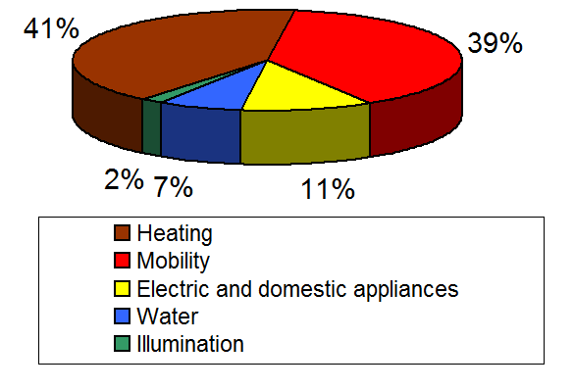
Figure 1 shows the energy consumption of an average Austrian household.
Figure 1: Energy Consumption of an average Austrian Household
The main part of the energy in Austrian households is used for heating and mobility. As this paper concentrates on houses themselves, the area of mobility is excluded in the following chapters. The other parts – electric and domestic appliances, water and illumination – play a minor part in the energy consumption but should also be observed accurately [Stigler, 2007].
As far as the used energy sources for heating are concerned, various changes could be observed during the last centuries. Oil is still the mostly used energy carrier with a share of 30% of the aggregate energy consumption. It is followed by natural gas (about 26%) and firewood (23%). Pellets and wood chips are nowadays used almost twice as much as coal [Statistik, 2008].

Czech Republic
In the Czech Republic, households are the second largest energy and electricity consumer. As you can see in Figure 2, they are responsible for 28% of total electricity consumption, which is about 15% lower than industry consumption [IEA, 2005].
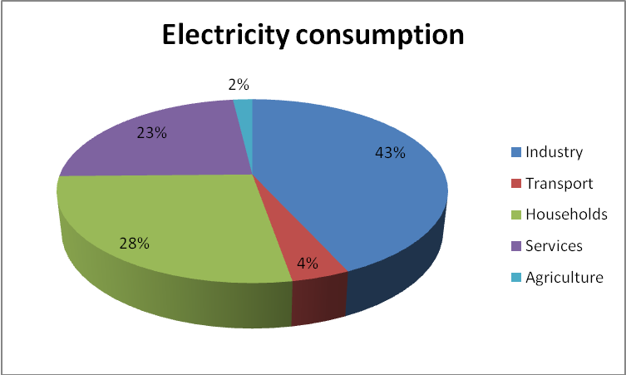
Figure 2: Total electricity consumption in the CZ
The largest amount of energy in Czech households is used for heating. Concretely, we usually used natural gas or already produced heat. These two sources contain more than 55% of total energy sources. Also it is possible to burn coal to produce heat, but nowadays this source of energy it is being replaced by natural gas or renewable resources, for example by biomass.
Electricity is nearly always used for running electric and domestic appliances, illumination and sometimes for water heating. As you can see in Figure 3 electricity contains nearly one quarter of total energy consumption of average household.
Also in the Czech Republic the biggest amount of energy is used for heating, it’s more than half if we don’t consider mobility. Following areas are water consumption and electricity used for running electronic and domestic appliances [ČMSS, 2008]:

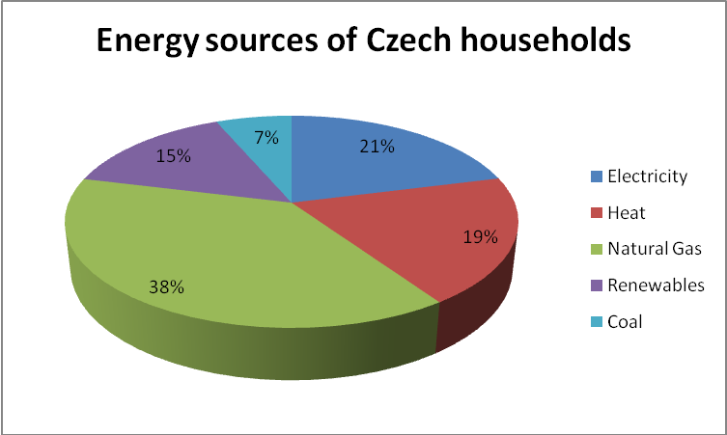
Figure 3: Energy sources of Czech households
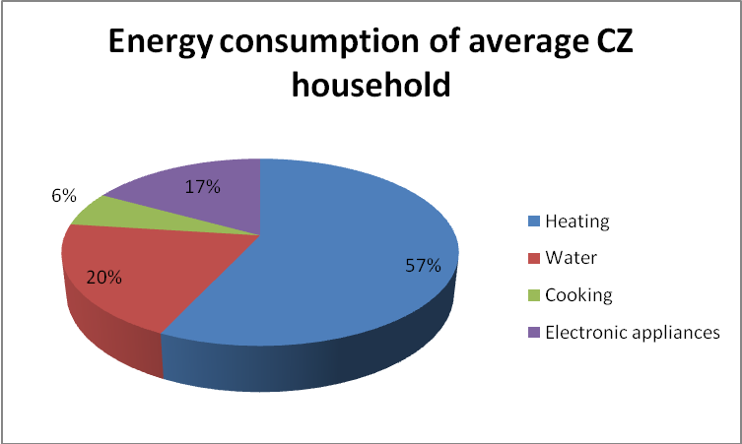
Figure 4: Energy Consumption of an averege Czech household

Savings Potential
There are various ways of saving energy with comparable little effort. The following chapters will deal with four main parts which are Heating and Cooling of houses, the illumination of rooms, water used for washing and hygienic issues and electric and domestic appliances which are used throughout the day.

Heating and Cooling
According to various experts, a reduction of the room temperature by one degree Celsius can cause a reduction of heating costs by almost 6% [Energiespar-fragen, 2008]. Lowering the average room temperature by 2°C could therefore save about 70 euro per annum. To achieve the adequate temperatures, a thermostat can be used, which costs 40 to 50 euro once.
The ideal temperatures in different rooms would be [orf.at, 2008]:
- Living room: 20 to 22°C
- Bedroom: 16 to 18°C
- Children's room: 20°C
- Bathroom: 24°C
The use of electric radiators seems to be very inefficient, as they cost a lot of money as well as electricity.
When going on holiday for more than two days, the heating can be lowered as well. The same applies to rooms which are not used very often like storage rooms or laundries.
One can also think about the air humidity inside the house. If it ranges around 30%, a temperature of 23°C is needed to feel comfortable. If the air humidity is in contrast raised to around 60%, which is also healthy for the air passages, only 21°C are necessary. Possibilities for an increase of the humidity are classical air humidifiers or the more decorative portable fountains.
To regulate the air humidity, also aerating is necessary. But this has to be done in the right way. In winter months, opening the windows for up to three times for about five to ten minutes should be adequate. Aerating for a longer period certainly means a waste of energy, as all heat disappears through the open windows. Another problem which has to be mentioned is that the walls are cooling if the windows are opened for a longer time.
Another possibility to make heating more efficient is to ventilate the radiators regularly. A lot of air inside the heating circulation can increase the heating costs dramatically. If it is possible, radiators should not be covered by curtains or be sheeted [orf.at, 2008].
Cooling, almost more than heating, costs a lot of electricity and money. Therefore, air conditions should only be installed if they are needed necessarily. Only rooms which are used regularly should bee cooled down and in addition, the temperature should only be reduced on extremely hot days.
The aspect of permanent cleaning of the filters is as necessary as the ventilation of radiators to guarantee an effective cooling. To reduce the operation of air conditions, aerating should be done in the cooler hours of the morning and rooms should be kept as dim as possible. Jalousies and sun-blinds can help a lot in this area [Energiespar-fragen, 2008].

Illumination
About 10% of Austria’s energy consumption falls upon illumination. One fifth of it is used by private households. According to various experts, about 80% of the electricity which is needed could be reduced by using energy saving lamps [klimaaktiv.at, 2008]. Therefore, the various options of illuminating a room should now be observed more intensively:
- Traditional light bulbs: Some people still persist on the use of traditional light bulbs because of the higher costs of energy saving lamps or their bulb holders which do not fit to an energy saving lamp. If this is the case, some references can be given: Try to use a light bulb with lower wattage and look if this is enough; Think about the installation of motion detectors in rooms which are used only for short times; Use bulbs with reflectors which are able to bundle the light and head the light in the right direction; Do not cover the light bulb with a dark lampshade [Energiespar-fragen, 2008].
- Energy saving lamps: The main advantages of energy saving lamps are a longer lifespan and the high light output. Whereas “normal” light bulbs convert only 5% of the energy to light and the residual 95% to heat, energy saving lamps are able to use 80% less electricity to achieve the same light output and much less heat. Their lifetime extends the one of traditional light bulbs by up to 15 times [klimaaktiv.at, 2008].
The disadvantage which is mostly named with reference to energy saving lamps is their input-delay. This deficit has already been minimized during the last years. The higher costs of an energy saving lamp are covered by lower electricity costs already after one year of using it.
- Fluorescent lamps: Today fluorescent lamps are mostly used in offices or production halls – therefore they play a minor role for private households. It still has to be mentioned, that they use 80% less energy than traditional light bulbs. Fluorescent lamps feature the same disadvantages as energy saving lamps do: input-delay as well as higher acquisition costs.
The myth, that switching on fluorescent lamps needs as much electricity as numerous hours of normal operation do, can not be reinforced.
- Halogen bulbs: Halogen bulbs are similar to traditional light bulbs but are refined by adding bromine or iodine. Thus, a halogen bulb creates an up to 60% higher light outputs and their lifetime can be extended.
Its higher operating temperature may be a problem when touching it. Also, it does not nearly save energy as much as an energy saving bulb does.
In general, one could save energy in the area of illumination by placing desks directly in front of windows, so that daylight can be used. In addition, some rooms do not have to be as highly illuminated as others: for example, hallways do not need as much light as offices. Light should be switched off when leaving a room for more than 15 minutes. Cleaning of lamps and shiners can also increase their efficiency.
Bright furniture and walls can help reflecting the light into various other areas of the room. Indirect lighting may be promotive for the atmosphere, but uses three times as much electricity as the direct one does.

Water
In the area of water, one has to think of body care and flushing as well as of doing the dishes and the laundry. To water the flowers in the garden, rainwater can be captured and used afterwards.
Heating of water causes about 10% of a household’s energy consumption. 60% of these are used for showering and bathing, 25% for doing dishes and laundry and the rest for scrubbing one’s hands.
When going on holiday, not only the room temperature can be lowered, but also the boiler can be switched off. If a water tap is dripping ten times per minute, 2000 litres of water are wasted per annum [Verbund, 2008].
The use of solar thermal collectors can partly replace electric boilers, gas- or oil-heating. Single lever taps regulate the water temperature rapidly and therefore save water and energy. With showering instead of bathing, up to 70 euro per annum can be saved [Verbund, 2008]. While lathering, the water can be turned off as well. There are also water saving shower heads which cost around 20 euro and have quite strong effects. Methods like water saving flushes or flow restrictors help to reduce the energy consumption in this sector as well.
As far as doing the dishes is concerned, dishwashers should be operated only fully loaded and with an energy saving program. If the dishes are not strongly polluted, 50°C should be enough to get them clean. It is not necessary, to wash the dishes with hot water before putting them into the dishwasher. When doing the dishes by hand, be sure to lock the drain before starting. Almost the same advices can be given for doing the laundry. Pre-washing is mostly unnecessary and lower temperatures are often sufficient.

Electric and domestic appliances
There is a high potential in making residential appliances more energy efficient, because these appliances and equipment use 30% of all generated electricity in OECD countries.
Electricity consumption is determined by wide range of indicators such as personal income, energy costs, house size, climate and patterns of use. These factors are the reason for variations in electricity consumption over the world. For example in 2000, households in North America consume 2.4 times more electricity than households in Europe [OECD/IEA, 2003].
In the area of electric and domestic appliances, we have to bear in mind cooking as well as operating of other kitchen appliances such as refrigerator or oven and from electric appliances we can mention all equipments that usually stay in stand-by mode like consumer electronics and information and communication technologies.
Concerning the higher income, nowadays we can effort to own more and more electric equipment, which leads to the 13% increase in consumption between 2000 and 2010. According to IEA projection standby power consumption will be the fastest growing one.
Now, I would like to introduce some concrete measures for saving energy and money in following areas:
- Cooking
- Refrigeration and freezing
- Consumer electronics
Cooking causes about 6% of a household’s energy consumption. We can save about 50% of energy by always using a pot-lid, when we cooked. Using pots with buckling bottoms can increase energy consumption by 30%. Also if we will cook in accurate amount of water we will save water as well as energy on account of shorter cooking time [www.infoenergie.cz, 2008].
One can achieve lower energy consumption through using a modern refrigerator and freezer from A+ or A++ category. By buying a new and more efficient appliance households can save about 45% of electricity. It’s also useful to keep the temperature inside a fridge above 5 °C, because the difference between 5 and 3 °C causes increase in energy consumption by 15% [RWE, 2008].
Consumer electronics include televisions, DVD players, audio equipment, computers and other home office equipment such as printers, scanners and faxes. Over the recent years there are more and more these devices in households so that energy consumption caused by running and letting them in standby mode rising as well. Saving energy in this area is mainly about changing our behaviour in using these appliances. By switching off the devices I mentioned above you can save much energy and money [RWE, 2008].

Information about Energy Savings
Dealing with this chapter we tried to find out as many information sources about energy savings as we could and also found the instruments that can help households learning about how they can reduce their energy consumption.
Our first sphere of interest was the activities of state institutions in providing information to public. If they arrange conferences or discussions, in which experts and public can participate or at least publish relevant information about energy savings on their website.
First possibly source I thought about, because it is common to all European inhabitants is definitely the website of European Commission. Finding information on this website is not that easy I thought, but in the environmental section one can find many measures useful in saving energy.
Second group of institutions that provide information about energy savings to public are energy suppliers, for example natural gas, electricity and water suppliers. In the Czech Republic these companies publish information about energy intensity of heating, cooking, water consumption and illumination. Also giving advice which measures can we easily put into practise and how should we change our behaviour related to energy consumption.
Finally, the last group of our interest were companies or institutions that are specialized in implementing energy savings measures. These measures are usually applied in municipal buildings and big companies or factories, although energy savings in households are not their main field, these companies publish principles and advices, whose abidance leads to lower energy consumption.

List of figures
Figure 1: Energy Consumption of an average Austrian Household 5
Figure 2: Total electricity consumption in the CZ 5
Figure 3: Energy sources of Czech households 6
Figure 4: Energy Consumption of an averege Czech household 6

Literature
EEA, 2008 URL: http://www.eea.europa.eu/themes/energy/indicators, May 2008
UKB, 2008 URL: http://www.umweltbundesamt.at/fileadmin/site/umwelt kontrolle/2007/UKB-8_12-Energie.pdf, May 2008
Stigler, 2007 Stigler, H.: Energie und Umwelt. Technische Universität Graz, Vorlesungsskriptum, 2007
Statistik, 2008 URL: http://www.statistik.at/web_de/statistiken/energie_und_umwelt/ energie/index.html, May 2008
Energiespar-fragen, 2008 URL: http://www.energiespar-fragen.at/, May 2008
Orf.at, 2008 URL: http://ooe.orf.at/magazin/treffpunkt/freizeit/stories/71079/, May 2008
Klimaaktiv.at, 2008 URL: http://www.klimaaktiv.at/article/archive/ 11914/, May 2008
Verbund, 2008 URL: http://www.energiespartipps.at/download/Verbund_ Energiespar_Tipps.pdf, May 2008
EC, 2008 URL: http://ec.europa.eu/environment/climat/campaign/control/ takecontrol_cs.htm
ČMSS, 2008 URL: http://www.cmss.cz/bydleni/bydlet_levneji/uspory_energie
OECD/IEA, 2003 OECD: Cool appliances – Policy Strategies for Energy-Efficient Homes
Infoenergie.cz, 2008 URL: http://www.infoenergie.cz/web/root/energy.php? nav01=38&nav02=117&nav03=116

